**TITLE**

**Troubleshoot Of Strain Gauge Kit**

# 1.0) Rational

A Straian Gauge is passive transducer which resistance changes as per applied pressure.The strain gauge is used as a Local Cell in weighing machine. In this practical student will able to measure the the pressure applied on a on strainin gauge

# 2.0) Course ouctomes achieved

1. Use strain gauge to measure applied pressure
2. Use various types of transduser and sensor to measure quantities. 3) Use advanced test and measuring instrument

## **3.0) Literature review**

## 

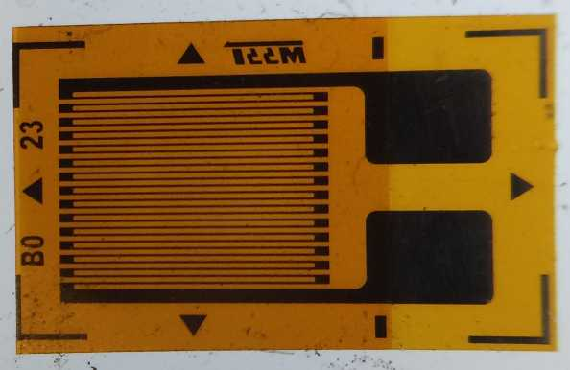

Fig no 1. strain gauge

**Definition of strain guage-:**

Strain is the amount of deformation of a body due to an applied force. More specifically, strain (ε) is defined as the fractional change in length, as shown in Figure 1 below.

Force

D

Force

L

ε = ∆-------L

L

**Fig no 2. Definition of Strain**

Strain can be positive (tensile) or negative (compressive). Although dimensionless, strain is sometimes expressed in units such as in./in. or mm/mm. In practice, the magnitude of measured strain is very small. Therefore, strain is often expressed as microstrain (µε), which is ε × 10–6.

When a bar is strained with a uniaxial force, as in Figure 1, a phenomenon known as Poisson Strain causes the girth of the bar, D, to contract in the transverse, or perpendicular, direction. The magnitude of this transverse contraction is a material property indicated by its Poisson's Ratio. The Poisson's Ratio ν of a material is defined as the negative ratio of the strain in the transverse direction (perpendicular to the force) to the strain in the axial direction (parallel to the force), or ν = –εT/ε. Poisson's Ratio for steel, for example, ranges from 0.25 to 0.3.

# The Strain Gauge

While there are several methods of measuring strain, the most common is with a strain gauge, a device whose electrical resistance varies in proportion to the amount of strain in the device. For example, the piezoresistive strain gauge is a semiconductor device whose resistance varies nonlinearly with strain. The most widely used gauge, however, is the bonded metallic strain gauge.

The metallic strain gauge consists of a very fine wire or, more commonly, metallic foil arranged in a grid pattern. The grid pattern maximizes the amount of metallic wire or foil subject to strain in the parallel direction (Figure 2). The cross sectional area of the grid is minimized to reduce the effect of shear strain and Poisson Strain. The grid is bonded to a thin backing, called the carrier, which is attached directly to the test specimen. Therefore, the strain experienced by the test specimen is transferred directly to the strain gauge, which responds with a linear change in electrical resistance. Strain gauges are available commercially with nominal resistance values from 30 to 3000 Ω, with 120, 350, and 1000 Ω being the most common values.

carrier

alignment marks

active grid

length

solder tabs

Fig no.3 Bonded Metallic Strain Gauge

It is very important that the strain gauge be properly mounted onto the test specimen so that the strain is accurately transferred from the test specimen, though the adhesive and strain gauge backing, to the foil itself. Manufacturers of strain gauges are the best source of information on proper mounting of strain gauges.

**Troubleshooting**

**Step 1-:** First we studied the strain gauage kit manual and then seen and studied the whole kit therotically .

**Step 2-:** Then we started to find the fault on the kit

* Checked each component in bridge are correctely mounted .
* Checked the resistance in each terminal.
* Apply known weight on bridge and measure the resistance of each arm.
* Apply the multiple of weight in linear variation on bridge .
* Test the sensitivity and linearit of bridge.

**Step 3-:** But unfortunately we don’t found the fault in the kit .

**Step 4 -**: Then we come to found the fault on strain gauge. The strain gauge was not properly connected to the output wire,it was detached

**Step 5-:** Then we shoulder that wire to the strain gauge **.**

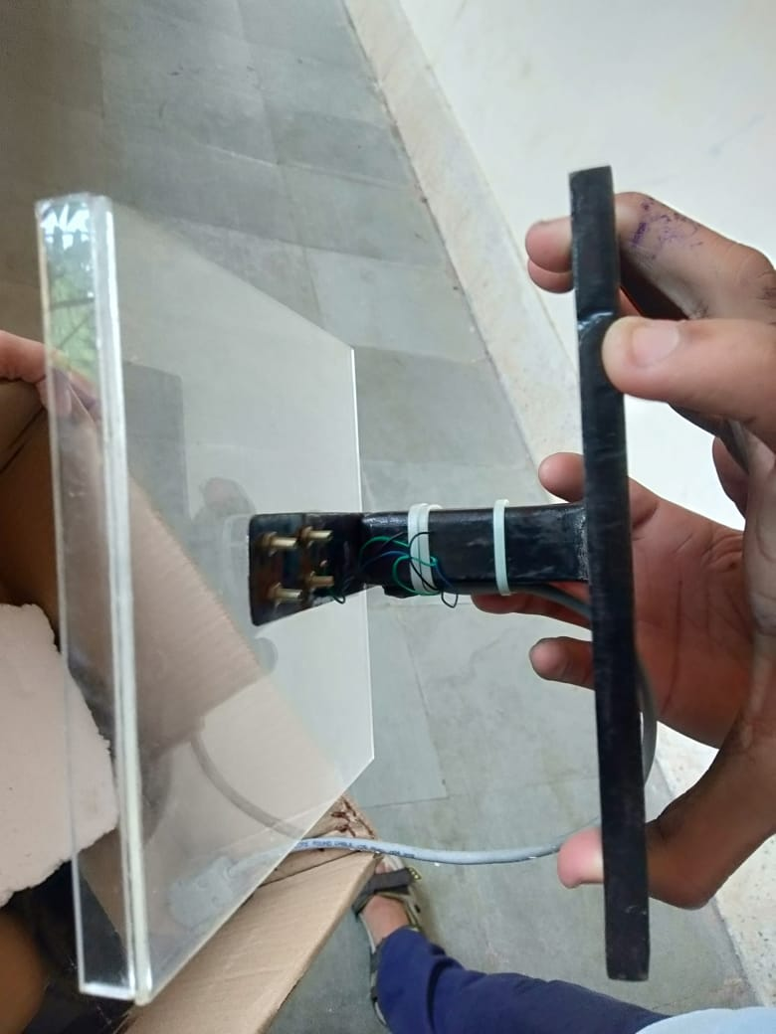

Fig no.4 strain gauge kit

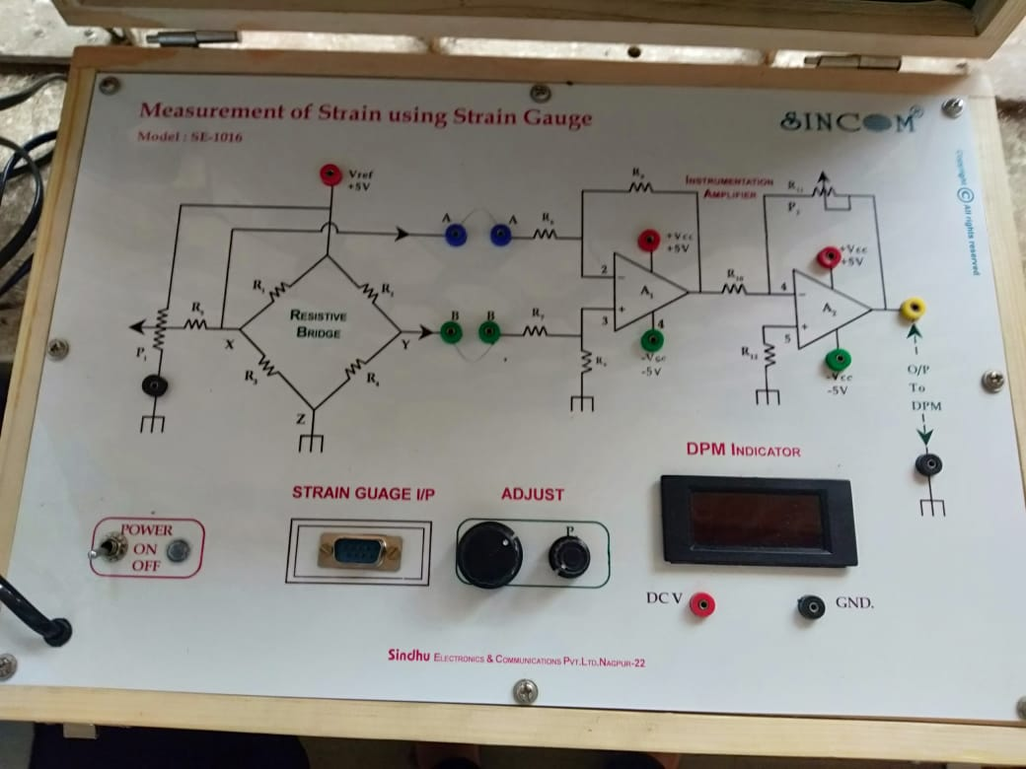

Fig no.5 strain gauge circuit

**Errors -:**

* Linearity is an error whereby the sensitivity changes across the pressure range. This is commonly a function of the force collection thickness selection for the intended pressure and the quality of the bonding.
* Hysteresis is an error of return to zero after pressure excursion.
* Repeatability - This error is sometimes tied-in with hysteresis but is across the pressure range.
* EMI induced errors - As strain gauges output voltage is in the mV range, even μV if the Wheatstone bridge voltage drive is kept low to avoid self heating of the element, special care must be taken in output signal amplification to avoid amplifying also the superimposed noise. A solution which is frequently adopted is to use "carrier frequency" amplifiers which convert the voltage variation into a frequency variation (as in VCOs) and have a narrow bandwidth thus reducing out of band EMI.
* Overloading – If a strain gauge is loaded beyond its design limit (measured in microstrain) its performance degrades and can not be recovered. Normally good engineering practice suggests not to stress strain gauges beyond ±3000 microstrain.

# Tips for better strain-gage measurements

The strain gage is one of the most common sensors used in automotive tests. Automotive test engineers use strain gages in materials test, durability tests, aerodynamics tests, and powertrain tests to measure load, pressure, and flow as well as strain. Being able to make accurate strain-gage measurements, therefore, is one key to delivering good test results.

* **1.Select a sensor with more capacity than you need.** According to Javad Mokhbery, president and chief technical officer of Futek Advanced Sensor Technology, (Irvine, CA), many test engineers do not take into account the extraneous load, moment, and fatigue life factors when selecting strain gages. The result is that the sensor fails earlier than it should.
* **2. Use bridge-completion resistors that are accurate and stable.** While a strain gage with four elements gives the highest output, strain gages are also available with one or two variable elements. When using a one-element or two-element strain gage, make sure that the elements that are not strain gages (also called bridge completion resistors) have the same accuracy and stability as the strain-gage elements.
* **3. Monitor sensor output during installation.** According to Mokhbery of Futek, one of the most common causes of strain-gage damage is mishandling during installation. He therefore recommends that you monitor the sensor output during installation by connecting it to the data-acquisition board or system.
* “Let the sensor talk to you at all times.” he says. “Doing so will help you avoid overloading the sensor, which could damage it, and will also minimize zero distortion after installation.”
* **4. Knock out noise.** Like all sensors, strain gages must minimize noise pickup to yield accurate results. The output of a strain gage is on the order of a few millivolts per volt of excitation, which means high-resolution measurement systems make measurements on the order of microvolts per count. It doesn’t take much noise to compromise these measurements.
* **5. Watch out for self-heating.** Self-heating of the strain gage can be a source of error when you mount the gage such that insufficient thermal mass exists to keep the gage cool. One solution, Barkis suggests, is to apply the excitation, wait for the reading to stabilize, take the measurement, and then remove the excitation. This will keep self-heating to a minimum.
* **6. Use a clean supply.** The bipolar supply needs to be clean, with as little ripple as possible. For this reason, Barkis says,you shouldn’t use the bipolar voltages from the PC bus, even though they are easily accessible. Some data-acquisition boards will have bipolar supplies designed specifically for exciting strain gages and other transducers. These supplies are certainly better than the PC’s supplies, but the cleanest supply to use for excitation voltage is a battery. Batteries are extremely quiet, although keeping them charged can be a problem. You certainly don’t want the battery to run down during a test run

**Advantages**

* Fast response time
* Ease of compensation for temperature effects
* Relative freedom from acceleration effects

**Disadvantages**

* Inability to provide lower ranges (all)
* Low level outputs (all)
* Sensitive to environmental vibration (unbonded)
* Media compatibility (semiconductor)
* Long term drift (all)
* Creep due to adhesive agents (semiconductor)

##### Strain Gauge Applications

* Precise determination of suitable measuring points
* Careful selection of appropriate strain gauges
* Precise bonding for torsion, bending, tractive force and pressure measurements
* Bonding with full, half and quarter bridges
* Precise multiple bonding to increase measuring accuracy
* Temperature, bending, and centrifugal force compensation
* In-house application of strain gauges (for test objects with a weight of up to one ton)
* On-site application of strain gauges

.